Student Guide 2023

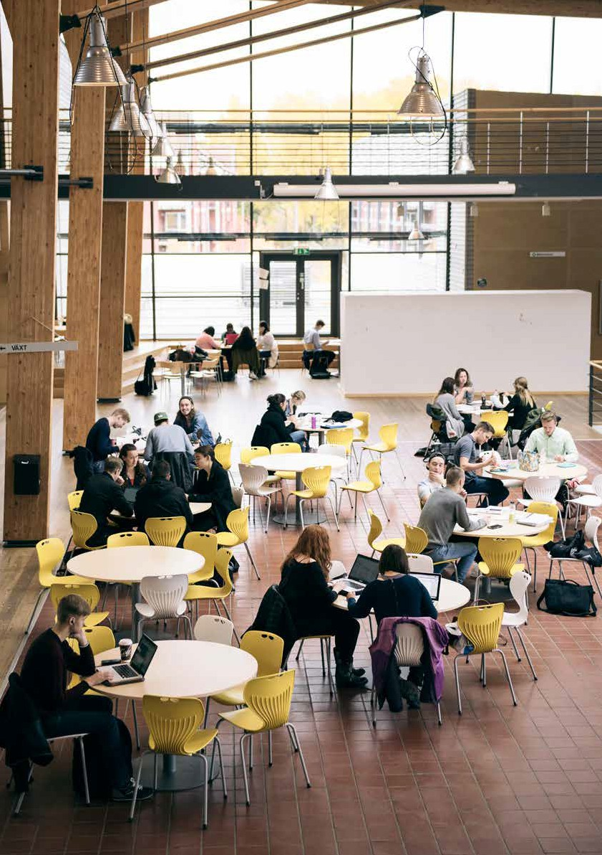

Faculty of Technology

# Contents

Introduction 4

Obtaining a student account 4

Register for a course 4

Tuition fees 5

Course syllabus 5

Schedule 5

The virtual learning environment Moodle 5

Written examinations at Linnaeus University 6

Study counselling 6

Career Center at Lnu.se 6

Career Guidance – LNU career counselling Service 6

Cooperation with companies 7

MyCareer – Career portal 7

Learning support for your studies 7

Student Welfare Office 7

Student Lounge 8

Infocenter/reception 8

IT support for students 9

Linnaeus Union/Linnékåren 9

Student associations at the Faculty of Technology 9

ESN Växjö 9

ESN 10

Kodkollektivet 10

Moodle 10

Freemover student 13

Programme and course syllabus 13

Optional courses/elective courses 13

Residence permit for non-EU/EEA citizens 13

International possibilities 14

The International Office 15

Internship abroad 16

More information about international possibilities 16

Exchange student 16

Course syllabus 16

Changes in your study plan 16

Transcripts of Records 17

Internship 17

Contact persons at the Faculty of Technology 20

Education Administrators 20

International Coordinators 21

Study counsellors 21

Collaboration Advisors 21

Available at a distance 21

Small glossary 22

First of all, welcome to Linnaeus University and to the Faculty of Technology!

In this handbook you will find useful information about your study period at our university. This short guide is complementary to the general guide for exchange students and the information contained is only for international students at the Faculty of Technology.

Please, keep it to hand, as it can be helpful later on.

Introduction

The Faculty of Technology at Linnaeus University consists of 9 Departments and administration. We are 350 people employed and we educate 2500 full-time students per year. The research is carried out in close collaboration with the South Swedish corporations. The faculty is located in both Växjö and Kalmar.

Obtaining a student account

You need a student account to begin studying at Linnaeus University. Via your student account, you can register, access course materials, access your e-mail account and other IT services. You obtain your student account at [Lnu.se/en/student/new-student](https://lnu.se/en/student/new-student). You can then log in at [Lnu.se/student](https://lnu.se/student) during your studies.

Contact the IT department if you need assistance: [it-support@lnu.se](mailto:it-support@lnu.se) or +46(0)480-44 67 00.

Register for a course

The decision of admission will be revoked if you do not follow Linnaeus university’s instructions concerning the registration procedure, including the last day of arrival. You need to be registered in order to study the course and for access to the schedule. If you are conditionally admitted, you will not be able to register. You must show, at the latest at the beginning of the course, that you have fulfilled the prerequisites for your programme or course. See [Lnu.se/en/student/new-student](https://Lnu.se/en/student/new-student) for more instructions.

If there are issues with your registration, contact your education administrator.

Tuition fees

Please note that your payment must be registered at our bank account by the following dates: December 15 for the spring semester, June 15 for the autumn semester. No exceptions or late payments are accepted. Payments received after the dates above will be returned, and the student in question cannot register to start the studies.

Read more: [Lnu.se/en/education/study-at-linnaeus-university/](https://lnu.se/en/education/study-at-linnaeus-university/tuition-fees-and-scholarships/) [tuition-fees-and-scholarships/](https://lnu.se/en/education/study-at-linnaeus-university/tuition-fees-and-scholarships/)

Course syllabus

In the course syllabus you will find the entry requirements, objectives, contents, examination and literature. Your programme syllabus and course syllabus can be found at [Lnu.se](https://lnu.se/en/student/during-your-studies/course-and-programme-syllabi/).

Schedule

After registration, you will find your personal schedule by logging in with your [student account](https://zero.comaround.com/link/98792717397d40b8a8835ba7145edfe1/) on Lnu.se.

You can also perform a search for your timetable, in our timetable system TimeEdit.

To find your introduction and schedule you need to:

1. Choose course or programme in the first box
2. Write either the course/programme name or code
3. Select the current semester
4. Click on “View Schedule”

[Search for course/programme introduction and timetable](https://cloud.timeedit.net/lnu/web/schema2/ri1Q7.html)

You can see your program start in the “new student”-box on the web-page for your program.

If you know your course/programme code, you can also go directly to: [Course introductions](https://lnu.se/en/search/?tags=Course%2Bintroduction)

[Programme introductions](https://lnu.se/en/search/?tags=Programme%2Bintroduction)

The virtual learning environment Moodle

Moodle is Linnaeus University’s virtual learning environment, where you have your programme room and your course room with information about your education. Log in via student account. See page 10 for further instructions in Moodle.

Written examinations at Linnaeus University

You must sign up for the written examinations within the sign up period. There is no possibility to sign up after the last date. You sign up via the student-web in your Ladok. If you have problems, contact your administrator before the sign up close (find the administrator of your course on the last page).

If you fail an examination, there is a possibility of signing up for a

re-examination later in the semester. Please note! If you have passed the examination in an earlier attempt, it is not allowed to participate again to top up your grade.

*Collect written exam*

Please note that written exams written is distributed digitally. You can find your exam(s) on My pages via the student web. Contact your teacher if your exam is not available on My pages.

Study counselling

With a study counsellor you can obtain individualised assistance with career guidance, planning your studies, approved leave from studies, cancellation of studies or changing programmes. We have two study counsellors at the Faculty of Technology, specialized in different programmes/study areas.

You can find the contact details under “Contacts”.

Career Center at Lnu.se

In our Career Center, that you can find on Lnu.se, possibilities and information is gathered. Have a look to see what there is to do! Apply for the mentorship programme before mid September, find the career counsellors, link to the job portal etc. [Career Center](https://lnu.se/en/student/job-and-career)

Career Guidance – LNU career counselling Service

The Career Counselling Service at Linnaeus University supports you when you are thinking about how your education, your experiences, work experience, and personal qualifications are to be summarised and become a powerful CV with a job application. Contact: karriar@ lnu.se

If you have general questions regarding your stay or studies at Linnaeus University you can contact Emma Krig (you will find the contact details under “Contacts”).

Cooperation with companies

We organize different career activities and events to make students meet companies and organisations. In several courses students are expected to learn more about the surrounding society by having contacts with local companies. It is common to make for example degree projects in cooperation with a company. In November every year we organize Career Day Technology.

Both the faculty staff members Jan Novak o Helena Belfrage (you will find the contact details under “Contacts”) and our career counselors working at Lnu Career, are available for you during your studies.

MyCareer – Career portal

MyCareer is a career portal for mediation of degree projects and jobs between students at Linnaeus University and employers in the region. The idea is that you as a student should be able to find an exciting degree project or job. The degree projects and jobs have been published by companies and organisations in the region. The portal is a collaboration between Linnaeus University and Graduateland: [Lnu.se/en/student/job-and-career](https://lnu.se/en/student/job-and-career/). Internship positions can also be published on MyCareer, so have a look!

Learning support for your studies

If you have some form of disability you can make use of the support measures for your studies that are available. Some examples of this include support in taking notes, assistance from sign language interpreters or being provided extended time for examinations. Are you or someone you know in need of support measures for your studies? Find more information on [Lnu.se/en/student/service-and-](https://lnu.se/en/student/service-and-support/studying-with-disability/) [support/studying-with-disability](https://lnu.se/en/student/service-and-support/studying-with-disability/).

Student Welfare Office

The Student Welfare Office has a preventative focus in its work relating to lifestyle issues and offers counselling. Contact information and activities can be found at [Lnu.se/en/student/](http://Lnu.se/en/student/service-and-support/student-welfare) [service-and-support/student-welfare](http://Lnu.se/en/student/service-and-support/student-welfare).

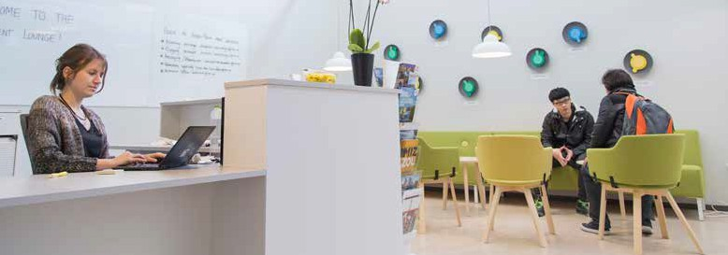

Student Lounge

At the Student Lounge, you can get help with general questions regarding your stay at Linnaeus University (such as admission, tuition fees, housing, international possibilities, career guidance, study counseling, student health etc.). [The Student Lounge](https://lnu.se/en/student/service-and-support/student-lounge/) is located in the main building in Växjö (house H, room 1313).

*Opening hours for Student Lounge*

Monday–Thursday 12:00–14:00

Infocenter/reception

As a student, you are always welcome to infocenter when you are looking for general information and service, directions or guidance concerning whom to turn to within the organisation. At infocenter, you can also:

* get a registration certificate showing your course registrations
* get a certificate of enrolment showing your completed courses, credits and grades
* buy profile products
* top up your printing credits
* collect your swipe card

They also take care of lost and found valuables.

*You find us here:*

In Kalmar they are located in Radix, Pedalstråket 11 at Universitetskajen. Opening hours are Monday-Friday 8 am-4 pm (closed for lunch 11.45-12.30). As from 1 January 2020 our opening hours are Monday-Friday 8 am-4 pm.

In Växjö they are located at the entrance of building H, and open Monday-Friday 07.45 am-4 pm. As from 1 January 2020 our opening hours are Monday-Friday 8 am-4 pm.

Phone:

+46(0)772-28 80 00

Email:

[info@lnu.se](mailto:info@lnu.se)

IT support for students

If you need assistance with IT-related issues, contact the IT Department: [Lnu.se/en/student/service-and-support/IT-Support](https://Lnu.se/en/student/service-and-support/IT-Support).

Linnaeus Union/Linnékåren

The student union, Linnaeus Union/Linnékåren, is there for you. They are involved in making the quality of your education better, and making sure your time at the university will be eventful with real social involvement. More information can be found at [Linnek.se/eng](http://Linnek.se/eng) or contact [info@linnek.se.](mailto:info@linnek.se)

Student associations at the Faculty of Technology

Student life is not only about studying; it is also about meeting new people, learning new things and growing as a human being.

Becoming engaged in student life can provide you with knowledge and experiences that may prove to be invaluable when you are looking for a job later in life.

The Student Union’s student associations linked to the Faculty of Technology are:

Lambda, SPIIK, VÄXT and WÄDUR.

ESN Växjö

One of the biggest student associations at Linnaeus University, run by students in Växjö, is a non-profit organization with the aim to ease the integration of international students and facilitate contact with Swedish students through cultural and social activities.

https://www.facebook.com/ESNVaxjo/

ESN Kalmar

Erasmus Student Network, Kalmar - is a non-profit organisation dedicated to international & local students at Linnaeus University in Kalmar with the aim to give them a great stay and to ease integration.

[www.facebook.com/ESNKalmar](https://www.facebook.com/ESNKalmar/)

Kodkollektivet

Kodkollektivet consists of a group of students with a great interest in programming, computer networking and other IT and business related topics. No previous experience in coding is necessary as long as you’re interested in learning. Facebook: [www.facebook.com/](https://www.facebook.com/kodkollektivet/) [kodkollektivet/](https://www.facebook.com/kodkollektivet/)

Moodle

You will spend a lot of time in Moodle, the virtual learning environment. Here you will find, among other things:

* Course material, instructions, and links
* Submissions
* Communication between teachers and students
* Course evaluations

If you do not find your course room, contact your course coordinator/ teacher.

Log in to [Moodle](https://moodle.lnu.se/) and you will find your courses under the menu “My courses”.

Get started with Moodle as a student Serviceportalen.lnu.se/en-us/ category/1488884

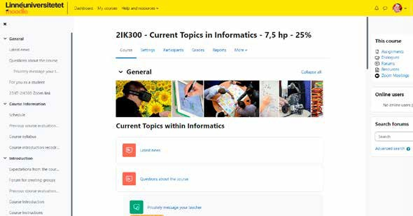

Each course room is unique, the teacher and the nature of the subject determine how the layout and course design affect the room.

*Communication in the course*

Usually, the course rooms start with the forums “Latest news” and “Questions about the course” that is used in facilitating communication in the course.

*Latest news*

Information from teacher to students. Teachers post general information such as news and reminders.

*Questions about the course*

Students can ask questions to the course instructor(s). All questions and answers are visible to the teacher and students in the course.

In the top menu you can find Help and resources. Via the blue button Guides button. to the left in the course room, you can find help and information about Moodle.

*Complete your profile with a picture*

* Click on your login/profile (upper right corner)
* Click on Preferences
* Click on Edit profile
* Add a picture
* Click “Update profile” to save

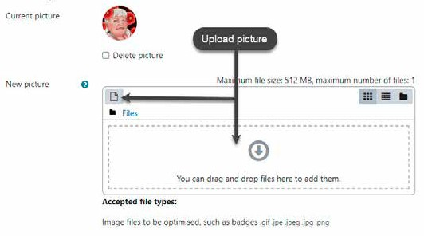

The benefits of adding a picture are, for instance, it enables the teacher to identify a student in a forum or assignment.

*Handing in an assignment*

During the course, you will most likely be required to upload a file as part of an Assignment. The settings might vary and are set by the teacher. A common setting is, that you must check the box to certify that it is your own work. The image below shows how it could look like to hand in a file.

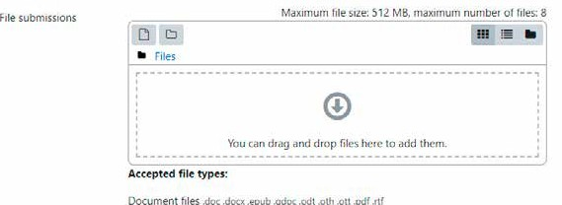

# Freemover student

*The following information applies to freemover students which means that you are studying a program or freestanding courses and have applied to Linneaus University by your own, i.e. you are not here as an exchange student.*

Programme and course syllabus

Your programme syllabus, which is your educational plan, describes your programme and which courses are included. In the course syllabus you will find the entry requirements, objectives, contents, examination and literature. Your programme syllabus and course syllabus can be found at [Lnu.se/en/student/during-your-studies/](https://lnu.se/en/student/during-your-studies/course-and-programme-syllabi/) [course-and-programme-syllabi](https://lnu.se/en/student/during-your-studies/course-and-programme-syllabi/)

Optional courses/elective courses

Elective courses the programme coordinator will give you suggestions on courses that you can choose to follow the program’s objectives.

Optional courses you can choose any course you want for a certain number of credits from Linneaus University. You find the selection at [Universityadmissions.se](https://www.universityadmissions.se/intl/login). Instructions on how to select your

mandatory and elective courses is provided in October for the spring semester and in April for the autumn semester.

Residence permit for non-EU/EEA citizens

Non-EU/EEA citizens must have been granted a student residence permit before entering Sweden. In order to qualify for a residence permit, you must have been granted admission to full-time studies (at least 30 credits per semester). The requirement for full time studies also means that you must be registered on 30 credits each semester i.e. you can under no circumstance keep a residence permit for studies, during a study break or approved leave.

The requirement for full time registration is especially important to consider if you cannot keep up with the study pace of your programme. The courses are given in fixed study periods and you

can only apply for an extended permit, if your uncompleted courses are available in period you apply for. See more at [Lnu.se/en/student/](http://Lnu.se/en/student/preparing-for-your-stay/residence-permit) [preparing-for-your-stay/residence-permit](http://Lnu.se/en/student/preparing-for-your-stay/residence-permit).

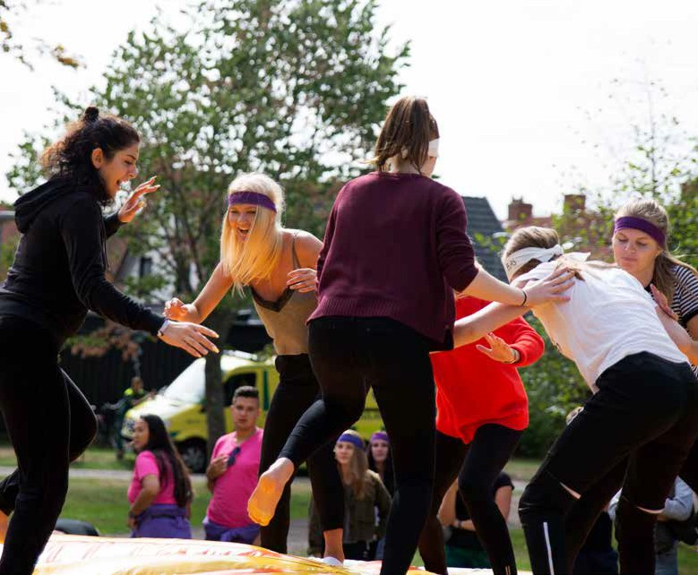

International possibilities

As a student at Linnaeus University, there are several opportunities for internationalization, such as for example exchange studies

or internship abroad. Depending on your programme, exchange studies and internship can be done on a specific semester or during the summer break. It is also possible to do directly after you have finished your programme. Students who are not European Union citizens might need to apply for a student residence permit in the European countries as well, even if they already have a Schengen residence permit for Sweden. It is also important to inform the Swedish Migration Agency when you apply for a residence permit in another country and to get information from them about how

to organize the Swedish residence permit again after the return to Sweden.

*Exchange studies* means that you study for one semester or one academic year at one of our partner universities or through networks and consortium that Linnaeus University are part of.

You apply for exchange studies the academic year before the exchange through the applications rounds that are open for all students at Linnaeus University. Every year, there are two application rounds for studies abroad:

October-November: All seats for the upcoming academic year.

February-March: Remaining seats from application round 1 for the upcoming academic year.

Applications for studies abroad are handled by the International Office. You will find more information about the requirements, the selection process and the application on their web page [Lnu.se/en/](https://lnu.se/en/student/international-possibilities/study-abroad/) [student/international-possibilities/study-abroad](https://lnu.se/en/student/international-possibilities/study-abroad/).

The International Coordinator at the Faculty of Technology and your programme manager can help you with questions such as when you can study abroad in your programme, what you can study and how we can transfer your credits. You can also find more information on the Moodle page International possibilities - Faculty of Technology [Mymoodle.lnu.se/course/view.php?id=23226](https://mymoodle.lnu.se/course/view.php?id=23226)

For questions e-mail [ftk.outexchange@lnu.se](mailto:ftk.outexchange@lnu.se) or [Katarina.ronndahl@lnu.se](mailto:Katarina.ronndahl@lnu.se)

The International Office

The International Office works for all students at Linnaeus University and are in charge of the application for exchange studies, nomination, contact with partner universities and all the practical issues of the mobility and the Erasmus grants (for studies and for internships). You can contact them at [outexchange@lnu.se](mailto:outexchange@lnu.se) , they also have drop-in hours at the Student Lounge, see details and contact info at [Lnu.se/en/student/international-possibilities](https://lnu.se/en/student/international-possibilities/)

Internship abroad

Erasmus Traineeship - Students can receive the Erasmus Traineeship for a period of 2 to 12 months if they are planning on carrying out their traineeship in another EU country, Iceland, Turkey, Northern Macedonia, Liechtenstein or Norway. Internship can be done within or outside your programme. You have to find the internship place yourself, but you can get the scholarship from us. Find out more on [Lnu.se/en/student/international-possibilities/erasmus-traineeship](https://lnu.se/en/student/international-possibilities/erasmus-traineeship/)

More information about international possibilities

Each autumn the International Office and the Faculty of technology organize information sessions and webinars about international possibilities.

For more information about international possibilities see [Lnu.se/en/](https://lnu.se/en/student/international-possibilities/) [student/international-possibilities](https://lnu.se/en/student/international-possibilities/)

Follow lnuabroad on Instagram, were students who are now abroad share their experiences.

# Exchange student

*The following information applies to you who are studying at Linnaeus University as an exchange student.*

Course syllabus

In the course syllabus you will find the entry requirements, objectives, contents, examination and literature. Your course syllabus can be found at Lnu.se. [Lnu.se/en/student/during-your-studies/course-and-](https://lnu.se/en/student/during-your-studies/course-and-programme-syllabi/) [programme-syllabi](https://lnu.se/en/student/during-your-studies/course-and-programme-syllabi/)

Changes in your study plan

What if the schedule for two courses collide? Contact the teacher before the course starts if you will not be able to attend an introduction meeting. See if there is a solution for you to follow both courses. Talk to the teachers.

If you need to change one or more courses that you have been accepted to, it might be possible if there are available places.

Check with International Office how to apply by sending them an email to [inexchange@lnu.se](mailto:inexchange@lnu.se) or visit them in the student lounge. Don´t forget to get the approval for the course change from your home university as well and update your Learning Agreement!

Transcripts of Records

You can print out a certificate yourself from Ladok, through your student account. For Exchange students a certificate for

successfully completed courses will automatic be sent at the end or after the semester to your home address (Erasmus students) or the International Office at your home institution (for other exchange students). The Transcript of Records will only show the courses you have successfully completed.

# Internship

*The following information applies to you who do your internship at Linnaeus University. You might have been selected to carry out an Erasmus internship at the Faculty of Technology. As intern, you are considered as a student and essentially have the same rights and obligations.*

All trainees are strongly recommended to join Linnaeus University orientation days and the information session given by FTK\s members. They are also welcome to courses up to 7,5 credits and are recommended to study Swedish.

Before your arrival in Sweden, you have most likely been in contact with your supervisor and have taken care of all the practical aspects of your internship (travel, accommodation, course choice, length and content of your project, etc.). At this point, you should have already met your supervisor; if not, do it as soon as possible!

Should you have questions, please contact the responsible for incoming trainees. You can find the details under “Contacts”.

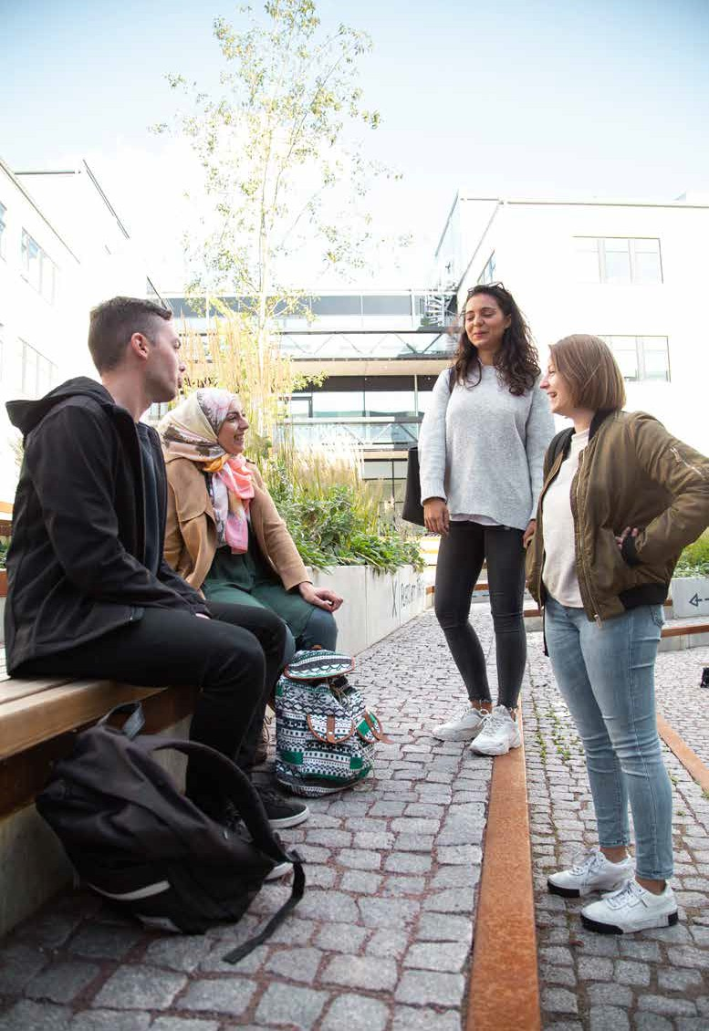

19

# Contact persons at

the Faculty of Technology

Education Administrators

Ligia Noia

*Education Administrator*

Subject: Physics, Kalmar Maritime Academy

Room: House Magna, Kalmar

Tel: +46(0)480 4976 05

E-mail: [ligia.noia@lnu.se](mailto:ligia.noia@lnu.se)

Paulina Nilsson

*Education Administrator* Subjects: Media Technology Room: House Magna, Kalmar Tel: +46(0)480 49 70 65

E-mail: paulina.nilsson@lnu.se

Elisabeth Walter

*Education Administrator*

Subjects: Information Systems and Computer Science

Room: House D, Växjö

Tel: +46 (0)470 76 87 19

E-mail: [elisabeth.walter@lnu.se](mailto:elisabeth.walter@lnu.se)

Ewa Püschl

*Education Administrator* Subjects: Computer Science Room: House D, Växjö

Tel: +46 (0)470 70 89 87

E-mail: [eva.puschl@lnu.se](mailto:eva.puschl@lnu.se)

Emeli Wickström *Education Administrator* Subjects: Mathematics and Electrical Engineering Room: House D, Växjö

Tel: +46 (0)470 76 74 64

E-mail: [emeli.wickstrom@lnu.se](mailto:emeli.wickstrom@lnu.se)

Signe Meijer

*Education Administrator* Subjects: Mechanical Engineering Room: N2074, N Building

Tel: +46 (0)470 70 80 83

E-mail: [amelie.rosenskold@lnu.se](mailto:amelie.rosenskold@lnu.se)

Milena Rusic

*Education Administrator* Subjects: Structural engineering Room: House N, Växjö

Tel: +46 (0)470 70 88 91

E-mail: [milena.rusic@lnu.se](mailto:milena.rusic@lnu.se)

Victoria Simonsson *Education Administrator* Subjects: Forest and Wood

Technology, Bioenergy Technology

Room: House N, Växjö

Tel: +46 (0)470 70 88 91

E-mail: [victoria.simonsson@lnu.se](mailto:victoria.simonsson@lnu.se)

You can also reach the faculty administration at [teknik@lnu.se](mailto:teknik@lnu.se)

International Coordinators

Katarina Rönndahl *International Coordinator Exchange student coordinator incoming and outgoing*

Room: M1026 (1st floor), M Building

Tel: +46 (0)470 70 86 26

E-mail: [katarina.ronndahl@lnu.se](mailto:katarina.ronndahl@lnu.se) or [ftk.inexchange@lnu.se](mailto:ftk.inexchange@lnu.se)

(if you have questions as an incoming exchange student)

[ftk.outexchange@lnu.se](mailto:ftk.outexchange@lnu.se) (if you have questions about going on exchange as a LNU student)

Study counsellors

Tina Karlsson

*Student Counsellor*

Subjects: Technology and Engineering, Maritime Applications, Forest and Wood technology Room: M1041, M Buildning

Tel: +46 470 70 88 97

E-mail: [tina.karlsson@lnu.se](mailto:tina.karlsson@lnu.se)

Bengt Persson

*Student and career counsellor* Subjects: Computer Science/IT or Mathematics

Room: D1122, D Buildning

Tel: +46 470 70 85 79

E-mail: [Bengt.c.persson@lnu.se](mailto:Bengt.c.persson@lnu.se)

*For general questions regarding your stay or studies at Linnaeus University please contact:* Emma Krig

*Career counsellor*

Office of Student Affairs ROOM: H Building, Växjö TEL: +46 470 70 82 80

E-mail: [emma.krig@lnu.se](mailto:emma.krig@lnu.se)

Collaboration Advisors

Helena Belfrage

Room: M1041, M building

TEL: +46 470 70 89 53

E-mail: [Helena.belfrage@lnu.se](mailto:Helena.belfrage@lnu.se)

Jan Novak

Room: M1041, M building

TEL: +46 470 70 80 16

E-mail: [Jan.novak@lnu.se](mailto:Jan.novak@lnu.se)

Available at a distance

Most staff can easily be reached also at a distance. Calls on Zoom can be set up when needed. Don´t hesitate to get in touch!

21

Small glossary

* Alumni

Former university students

* Assignments

are often submitted via Moodle. Carefully check the last date and time for submission, as the folder could have a closing time.

* Conditionally admitted You must show that you meet the entry

requirements before the start of the course. The entry requirements are stated in the programme or course syllabus.

* Dean

Head of the faculty

* DiVA

Database for research publications and degree projects

* Eduroam

LNU’s wireless network

* Examiner

Teacher that has the judicial right to certify grades

* FTK

Short for the Faculty of Technology

* Laboratory lessons

can be a part of the examinations of the course. Attending is mandatory.

* Ladok

National study documentation system where student details are kept, such as grades, certificates, results and registration.

* Moodle

is the virtual learning environment where students and teachers meet and work.

* Prefekt

Head of Department

* Query

Smaller written exam

* Registration

At the start of the course, you must confirm your place by completing your registration in Ladok, via the student web.

* Seminar

Teaching method that involves group discussions/ dialogue

* TimeEdit

University system for viewing schedules and booking group rooms. After registration, you find your personal timetable on the student web.

* Tuition Fee

A fee that international students who are not citizens of the EU, EEA or Switzerland are required to pay for their studies

Open your mind to new opportunities

