Isolation of Cyanophage from the Baltic Sea

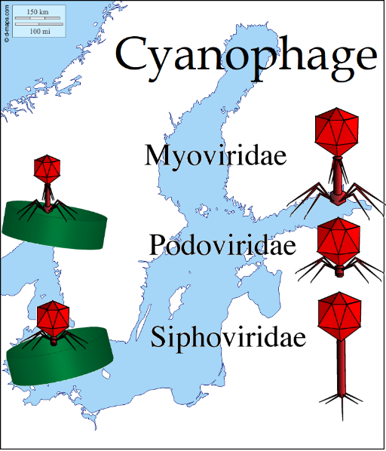
The globally abundant picocyanobacterium Synechococcus is a major phytoplankton in the Baltic Sea microbial ecosystem (Figure 1). Viruses that infect Synechococcus, collectively called cyanophages, have been identified as important regulators of mortality in marine environments, ultimately determining the role of Synechococcus in the food web. However, the significance of Synechococcus-cyanophage interactions in the Baltic Sea are largely unknown. Because coastal and estuarine cyanophages tend to be regionally- and host-specific, it is likely that Baltic cyanophage have co-evolved with Baltic Synechococcus, and have an evolutionary distinct relationship. The aim of the project is to isolate novel cyanophage from the Baltic environment using recently attained isolates of Synechococcus from the Baltic Sea. This will give information about the types of cyanophage present in the Baltic Sea as well as the host specificity of the isolated strain(s). The results of this project will provide a foundation for research that characterizes Baltic cyanophage and Synechococcus-cyanophage interactions, and provide cyanophage isolates to be used as model system for laboratory studies of Synechococcus-cyanophage infection dynamics.

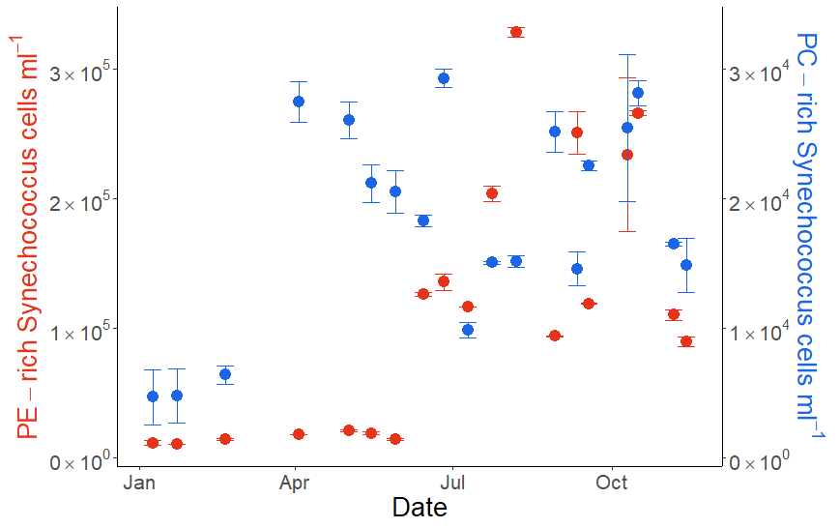
Methods be used
Viral fraction seawater concentrations for Synechococcus culture incubations
Top agar overlay to pick individual viral strains
Viral incubations with multiple Synechococcus strains to determine host specificity
Viral identification using PCR gene amplification or Transmission Electron Microscopy
Figure 1. Synechococcus are observed year round at the LMO sampling station during the 2018 growth season. Differing ecotypes of Synechococcus have separate growth dynamics throughout the year and may similarly experience separate viral infection dynamics. Observed here are phycoerythrin (PE) and phycocyanin (PC)-rich Synechococcus ecotypes, with ecological niches defined by their light absorption characteristics.

Supervisors: Hanna Farnelid and Christien Laber
hanna.farnelid@lnu.se christien.laber@lnu.se

