Abundance of Synechococcus in free-living and particulate size fractions
Synechococcus is a globally significant picocyanobacterium (<2 µm in diameter) that is widely distributed. In the Baltic Sea, Synechococcus has been reported to contribute as much as 80% of the total cyanobacterial biomass. Because of their small size, they have an advantage in nutrient uptake and are thought to be less susceptible to gravity settling compared to larger phytoplankton. The main ways of removal of Synechococcus from the water column are thought to be through grazing, moving energy to higher trophic levels or viral lysis, fueling growth in lower trophic levels. However, increasing evidence suggests that Synechococcus cells may form aggregates and/or be associated to larger particles which could act as a vector for removal of Synechococcus cells from surface waters into deep waters and sediments and a carbon sink. In this project, the abundance of Synechococcus cells in free-living and attached size fractionated seawater will be investigated using quantitative (PCR). The project will include optimization and development of novel assays targeting Synechococcus and specific clusters of Synechococcus. The results will contribute to an understanding of the ecology of Synechococcus cells and the faith of Synechococcus biomass in the Baltic Sea. Knowledge of the removal of Synechococcus is of high interest for global biogeochemical cycles and the marine environment in a changing ocean.

Methods:
Primer development
qPCR experiment design
qPCR optimization
Analysis of results

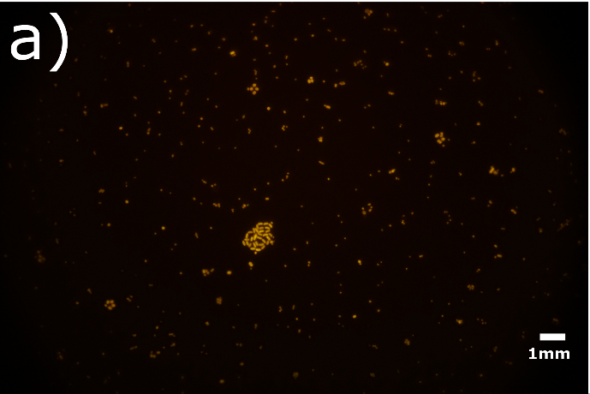
Figure: Epifluorescence image of Synechococcus cells showing both free-living and clusters of cells. Image courtesy: Javier Alegria Zufia.

Supervisors: Hanna Farnelid and Laura Bas Conn
Contact info: hanna.farnelid@lnu.se

