Identification of Synechococcus ecotypes in the Baltic Sea Proper
Synechococcus is a small cyanobacterium and a significant primary producer that is widely distributed on a global scale. Synechoccocus is highly adaptive and future predictions are that it will increase further in abundance and expand to higher latitudes. The genus is represented by numerous ecotypes, adapted to various environmental conditions including light, temperature, salinity and nutrients. In the Baltic Sea, a diverse community of Synechococcus has been reported but to which extent the diversity is represented by phylogenetically distinct ecotypes has not been investigated. In this project, bioinformatic methods will be used to explore 16S rRNA gene amplicon data from the Linnaeus Microbial Observatory (LMO) time series to identify Synechococcus ecotypes. The LMO dataset represents a high resolution sampling of water from the Baltic Sea Proper providing possibilities for discovering seasonality and environmental controls of organism groups. An in-depth analysis of Synechococcus ecotypes and their seasonality will provide new knowledge on their distribution patterns and physiology. This knowledge is essential for understanding the consequences of global change for marine ecosystems in a future ocean.
The project is bioinformatics based on already available data and can be performed distance based.
Methods and skills:
Exploring ecological questions in molecular datasets
Analysis of amplicon sequence data
R program (analysis and visualization)
Statistical analysis of sequencing data
Phylogenetic analysis
Statistical analysis

Supervisors: Hanna Farnelid and Christien Laber
Contact: hanna.farnelid@lnu.se

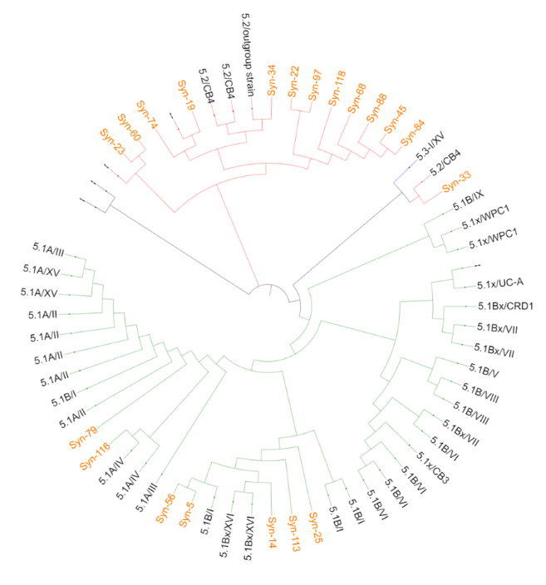
Figure. Phylogenetic tree of Synechococcus amplicon
sequence variants (ASVs) and representative sequences
of Synechococcus subclusters 5.2 and 5.1A and 5.1B
from a fjord transect in the North Sea.

